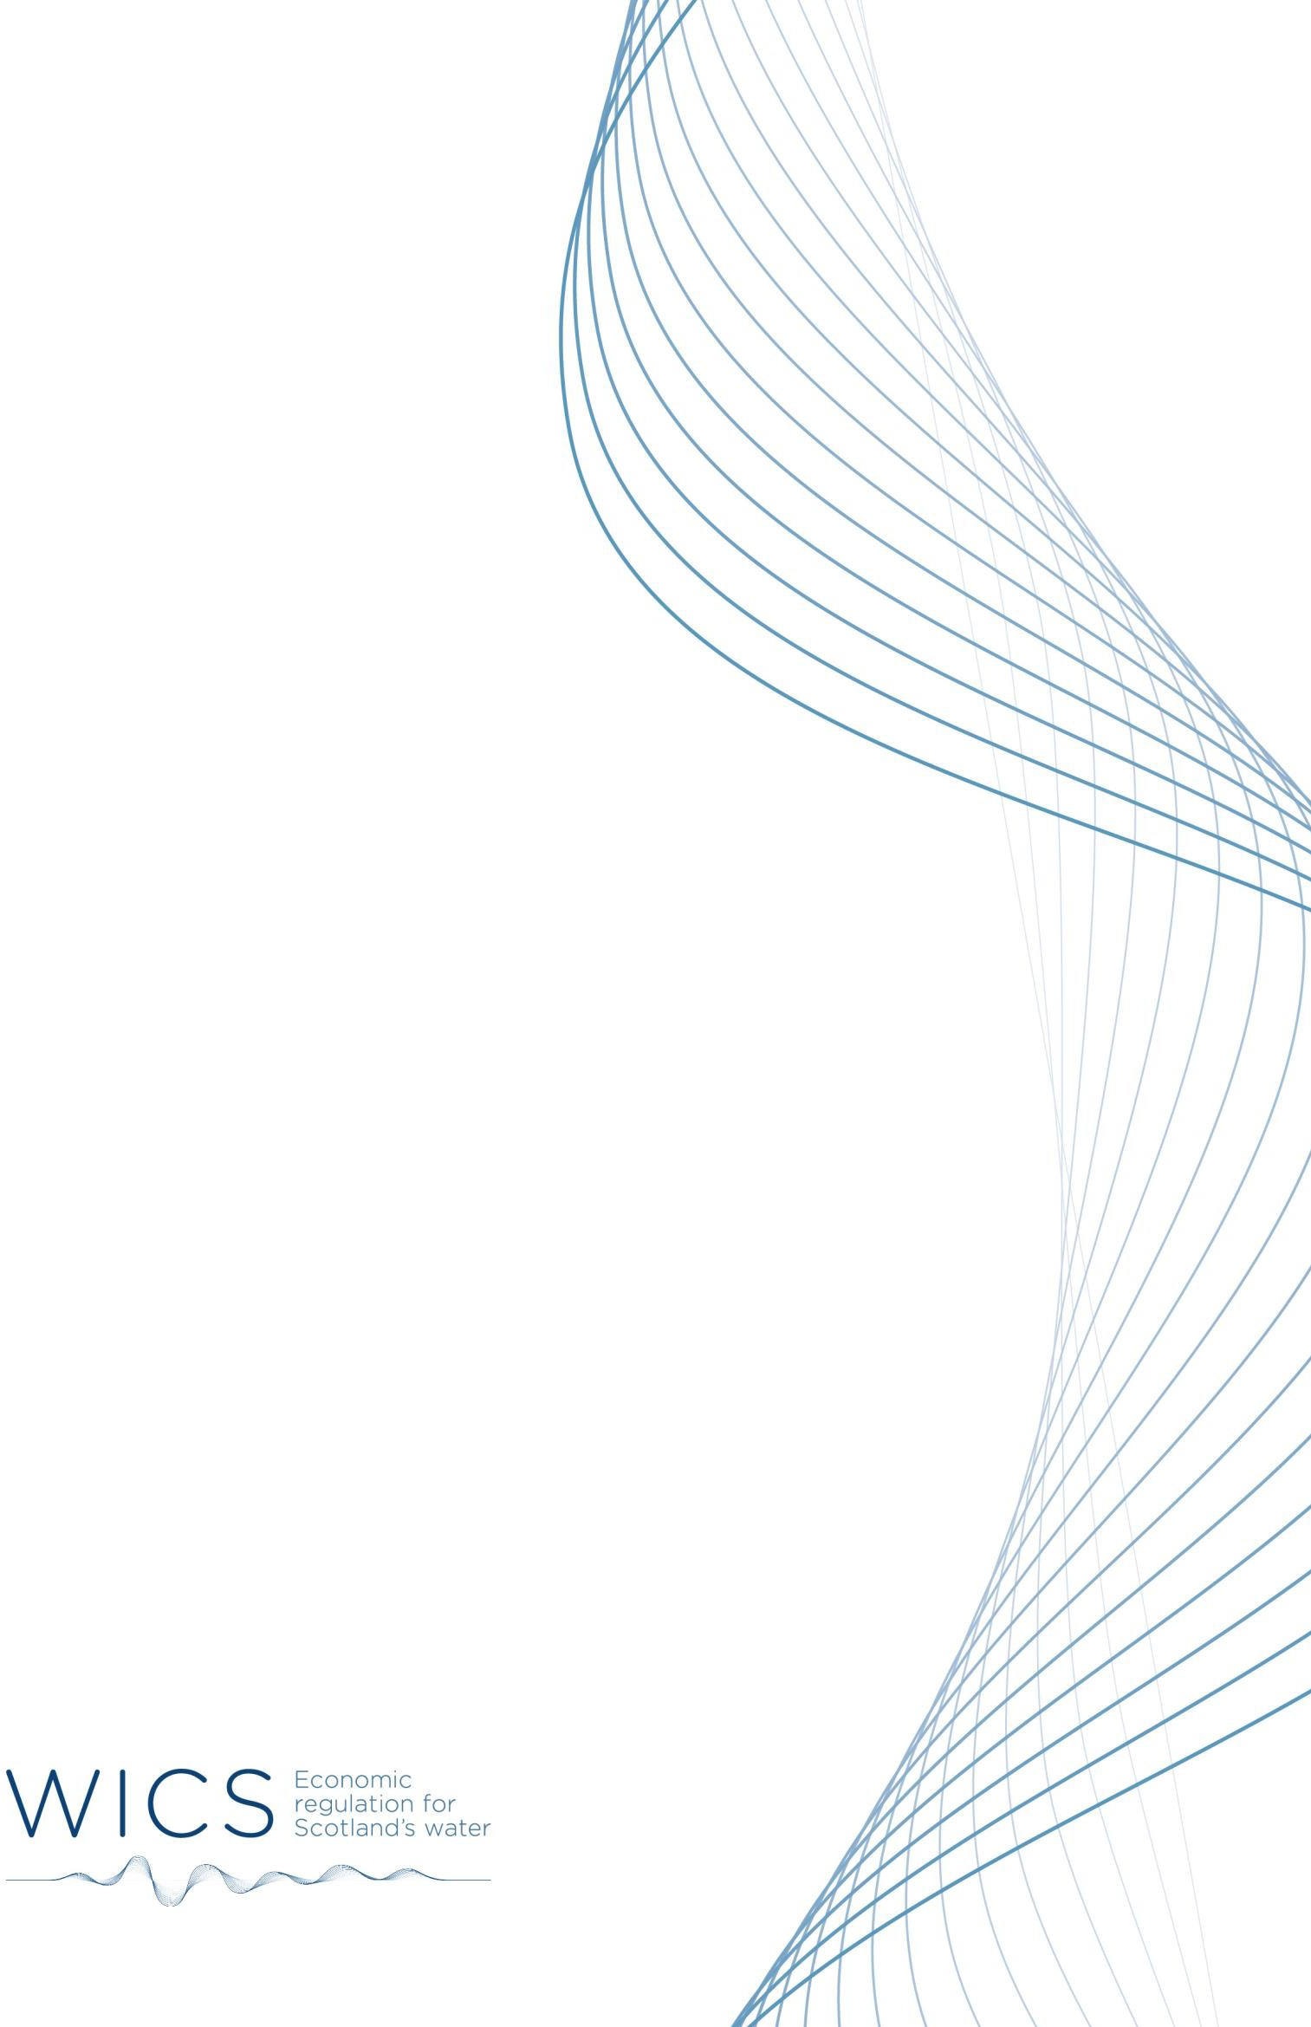

GENDER
REPRESENTATION REPORT
For the reporting period 1 April 2023 to 31 March 2025
October 2025

Introduction

The Gender Representation on Public Boards (Scotland) Act 2018 was introduced to help address the historic and persistent underrepresentation of women in public life.

Section 1 of the Act sets the “gender representation objective” for a public board that 50% of non- executive members are women. The Water Industry Commission for Scotland (WICS) is listed as one of the public authorities in schedule 1 of the Act. As such, WICS is required to report on the gender representation of the Board at least every 2 years. This information is also reported annually within WICS’ annual report.

The ‘Appointing Person’, as defined in the statutory guidance as responsible for appointments to WICS’ board, is Scottish Ministers.

This report covers the period 1 April 2023 to 31 March 2025 and provides information on WICS’ Board membership and appointment arrangements.

WICS’ Board membership

WICS’ Board comprises up to five non-executive members and the Chief Executive.

The recruitment exercise for WICS’ Board members is run by the Scottish Government’s public
appointment team with support from WICS’ Scottish Government Sponsor department.

Appointments are for fixed terms of up to four years with the possibility of re-appointment, subject to evidence of effective performance and satisfying the skills, knowledge and personal qualities required on the Board at the time of re-appointment.

Details of WICS’ Board appointments during the period are outlined in the table below.

Name | Position | Initial appointment date | Re-appointment date | Official end date
Donald MacRae | Chair | 01/07/2016 | 01/05/2022 | 30/04/2026  (R.21/10/24)
Jo Armstrong | Member | 01/07/2016 | 01/07/2020 | 30/06/2024  (R.14/02/24)
Ronnie Hinds | Interim Chair | 21/10/2024 | - | 31/12/2025
Ronnie Hinds | Interim Member | 15/07/2024 | - | 15/07/2025
Morag Sheppard | Interim Member | 15/07/2024 | - | 15/10/2025
Ann Allen | Member | 01/07/2020 | 01/07/2024 | 30/06/2028  (R.30/04/25)
Robin McGill | Member | 01/01/2020 | 01/01/2024 | 31/12/2027

The gender representation of WICS’ non-executive Board Members during the period 1 April 2023 to 31 March 2025 was:

Date | Total | Female | % female
1 April 2023 | 4 | 2 | 50%
14 February 2024 | 3 | 1 | 33%
15 July 2024 | 5 | 2 | 40%
31 March 2025 | 4 | 2 | 50%

During the year, Board membership varied and ranged from three to five members, with female representation varying between 33% and 50%.

Donald MacRae resigned from the Board on 21 October 2024.
Jo Armstrong resigned from the Board on 14 February 2024.
Ronnie Hinds was appointed interim Chair from 21 October 2024.
Ann Allen resigned from the Board on 30 April 2025.

